ONE CLOUD CPU
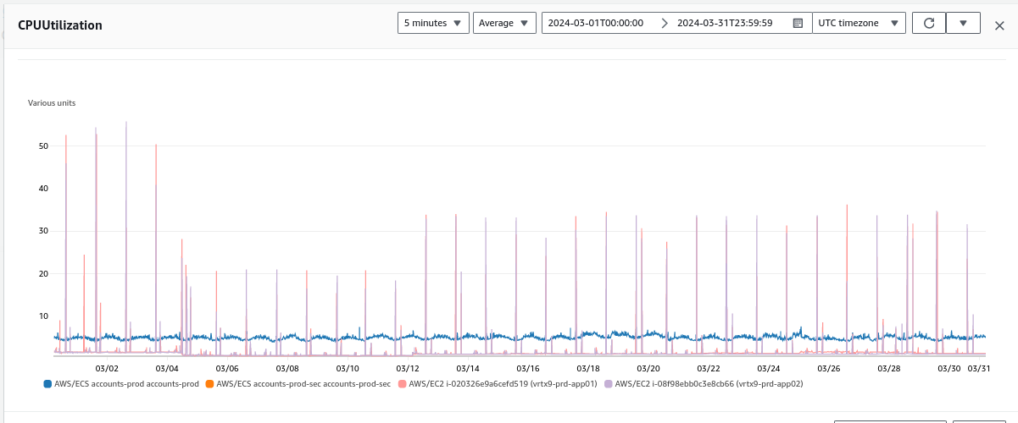
ONE CLOUD MEMORY
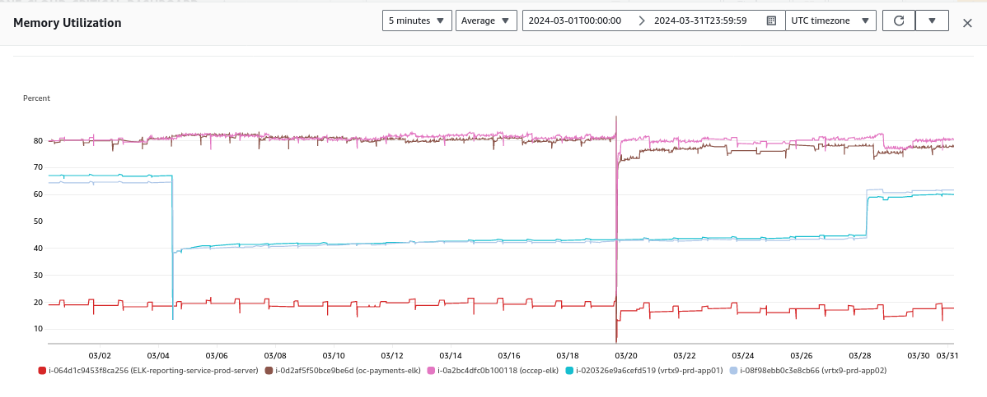
OC CEP, Billing API Gateway Count
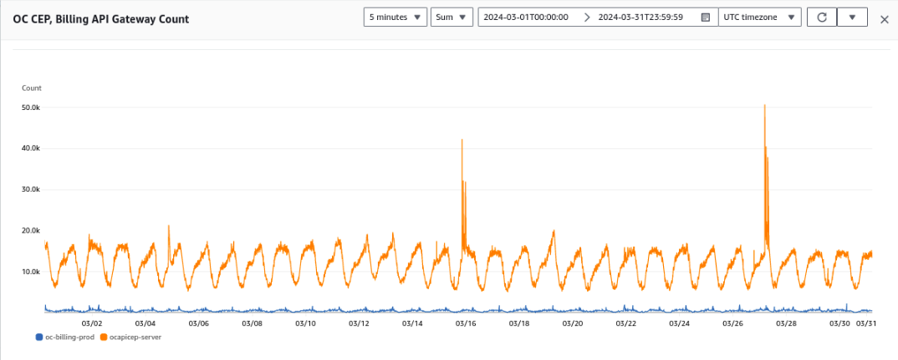
OC CEP, Billing API Gateway Latency

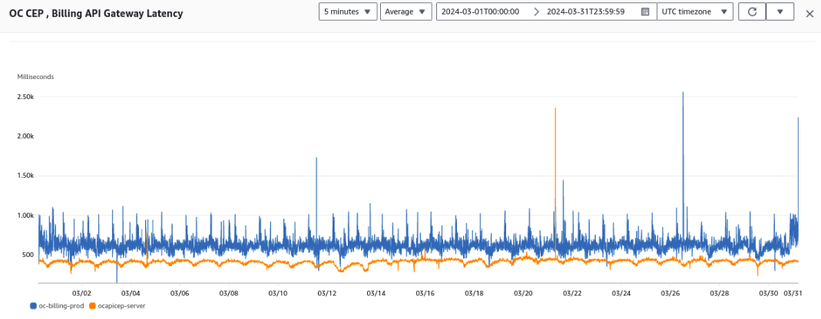
OcAuth Duration, Invocation
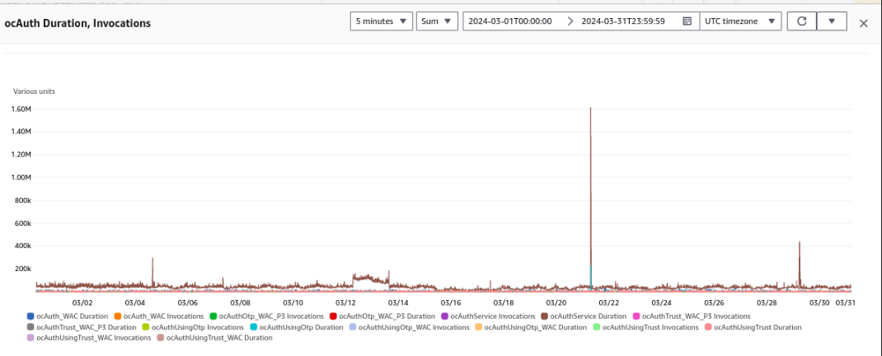
OcRegister Duration, Invocation
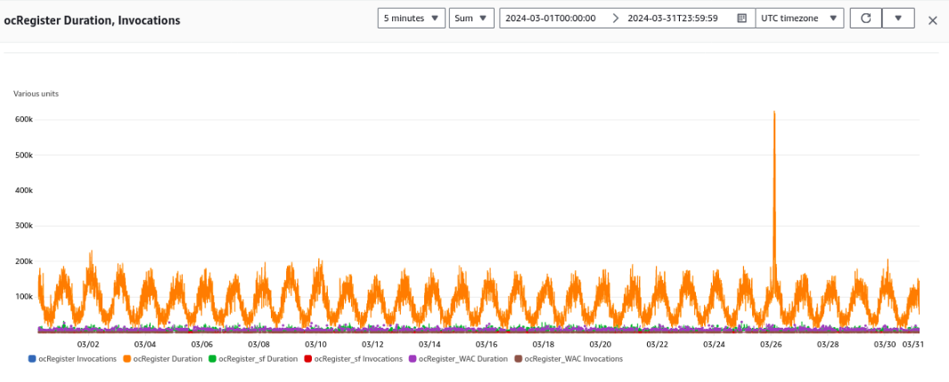
OcGetUser Profile Duration, Invocation

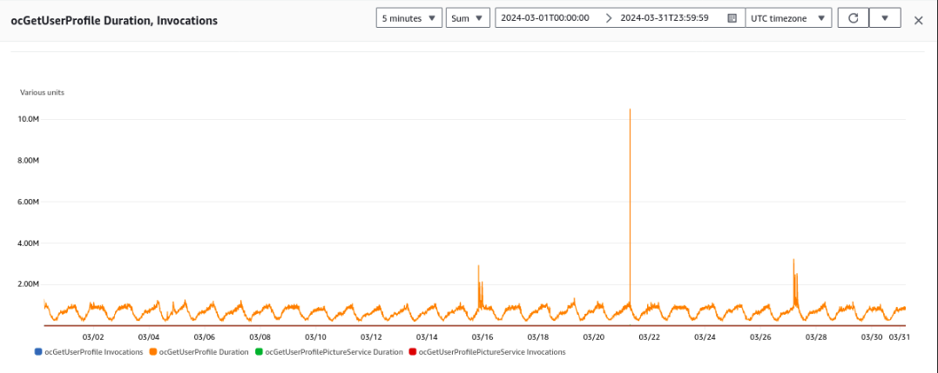
XCLOUD EU West Ireland - CPU

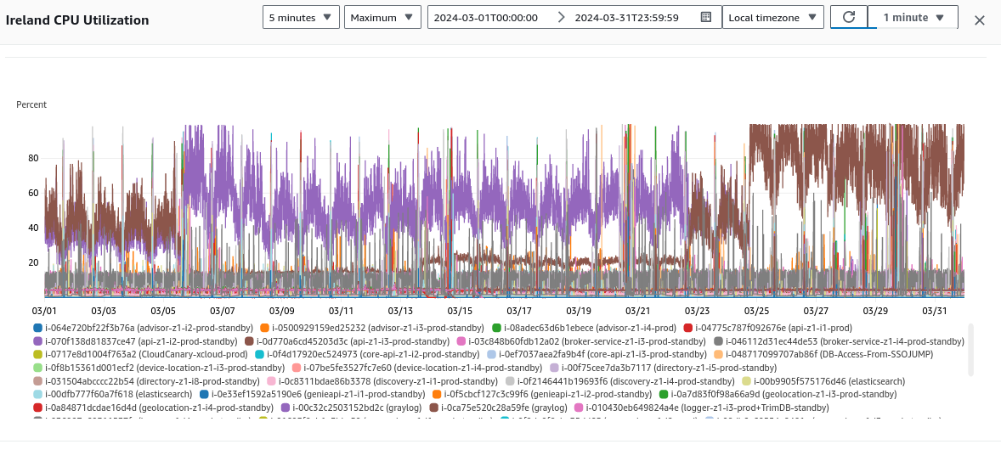
XCLOUD EU West Ireland - MEMORY

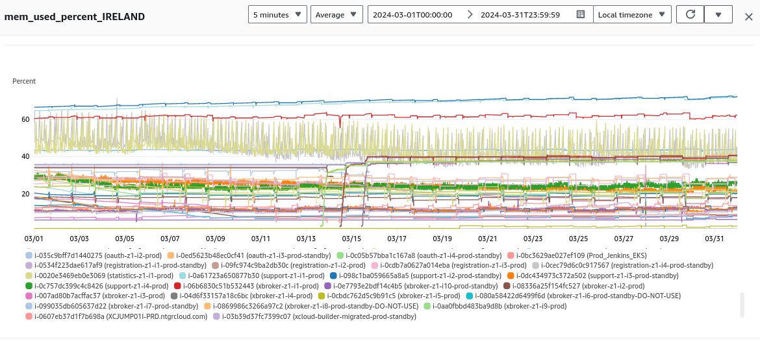
XCLOUD US WEST OREGON - CPU

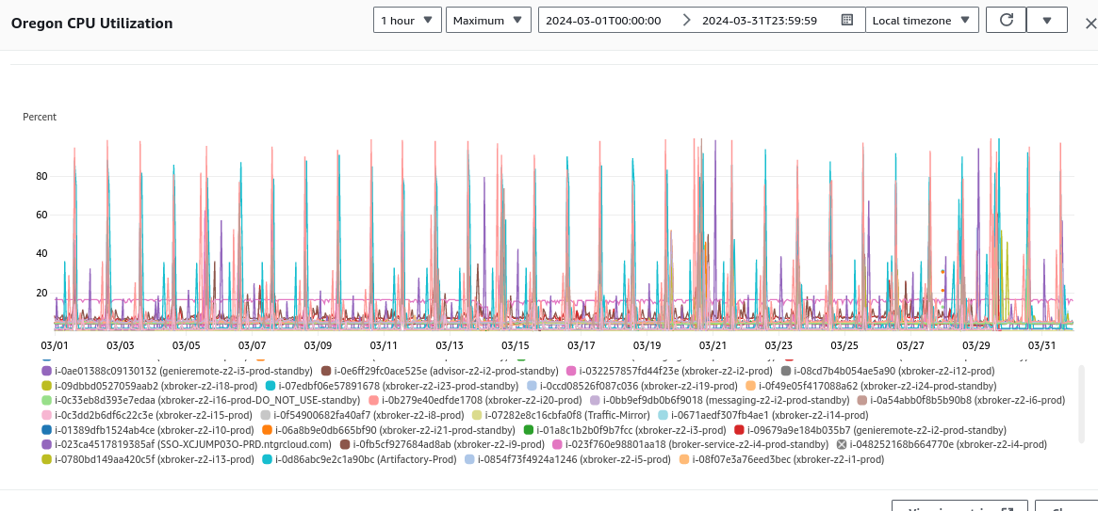
XCLOUD US WEST OREGON - MEMORY

